Github URL

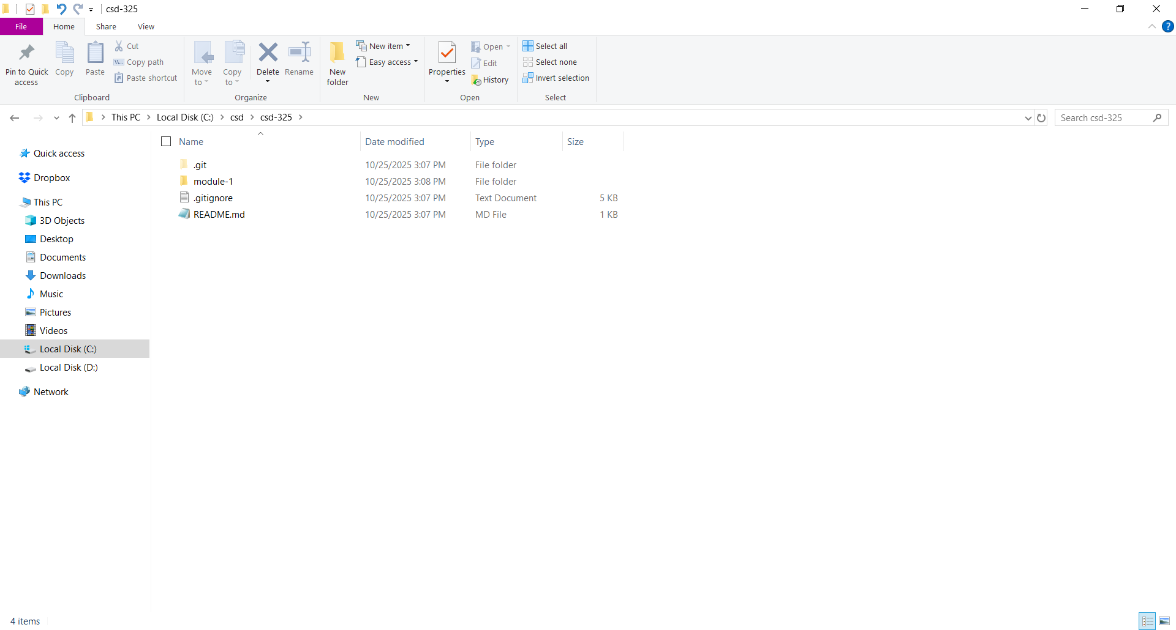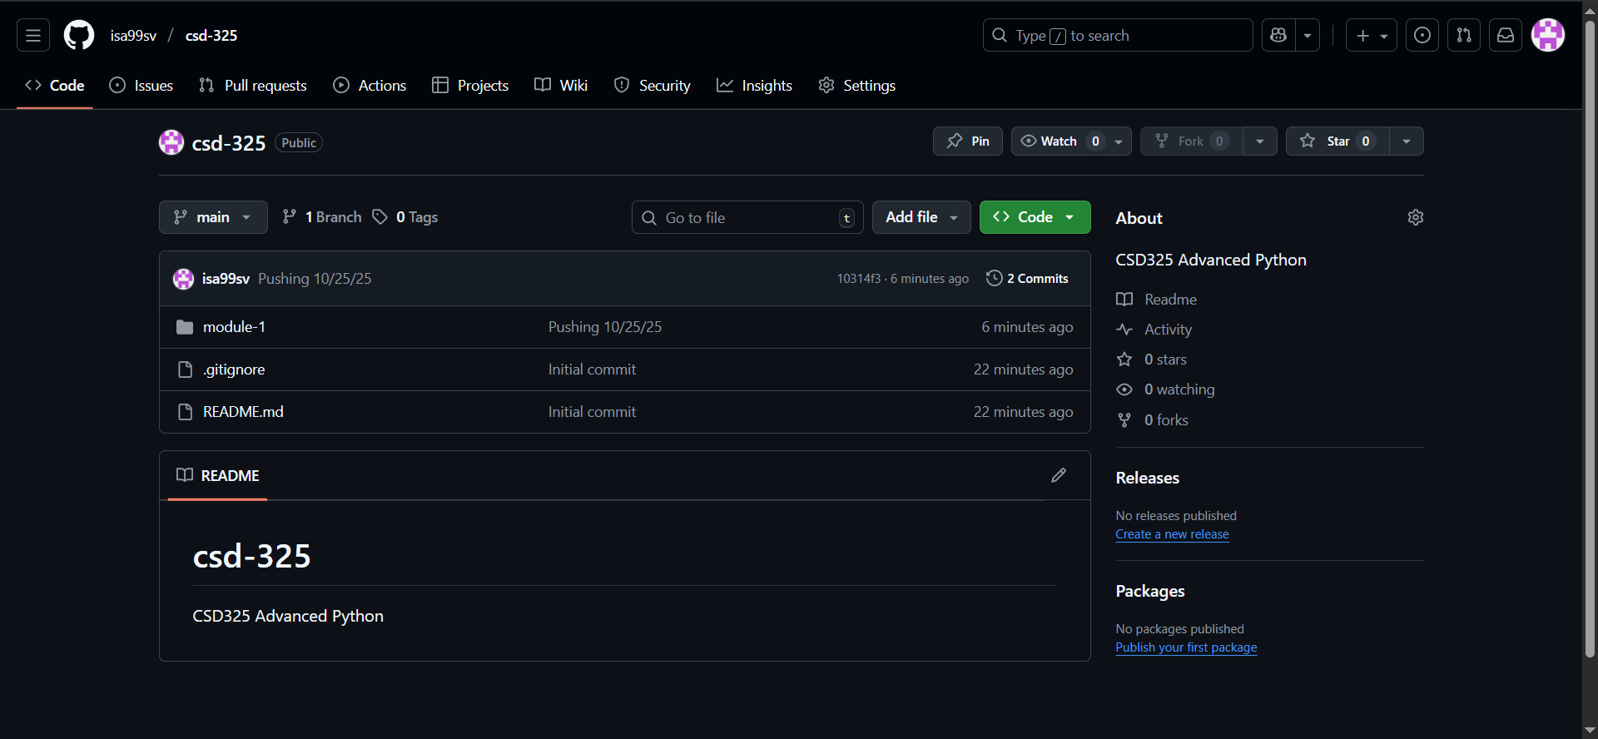[[**https://github.com/isa99sv/csd-325.git**](https://github.com/isa99sv/csd-325.git)](https://github.com/isa99sv/csd-325.git)